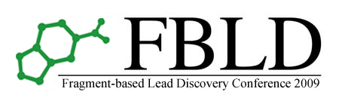

FBLD 2009 Conference Registration Form

21st – 23rd September 2009

Delegate Information:

Name
Organisation
Address
Email
Telephone

Conference Details:

Registration for the conference is from 11.00 Monday 21st Sept - 14.00 Wednesday 23rd Sept 2009
(includes bed & breakfast accommodation 21st & 22nd September and all meals and refreshments)

Registration type | Price | Please tick
Full Conference Registration | £480
Full Conference Registration – MGMS Member | £460
Student Registration | £340

Additional Accommodation | Price | Please tick
Bed & Breakfast accommodation Saturday 19th September | £45.50
Bed & Breakfast accommodation Sunday 20th September | £45.50
Bed & Breakfast accommodation Wednesday 23rd September | £45.50

Pre-Conference Workshop - Sunday 20th September 2009:

Pre-Conference workshop registration is from 10.00 - 17.00 Sunday 20th Sept 2009
(includes lunch and refreshments)

 | Price | Please tick
Pre-Conference Workshop Registration | £150

TOTAL:

Payment options:

Please select one of the following payment options:

Cheque / Invoice / Bank Transfer / Card Payment

- Cheque
Cheques should be drawn on a UK bank and made payable to ‘University of York’

- Invoice
Please indicate below name and address to which the invoice should be directed:

- Bank Transfer
Please include your full name and the reference chem_C00852 when making the transfer
Account name: The University of York
Bank address: HSBC, 13 Parliament St, York, YO1 8XS
Account no: 20898201
Sort code: 40-47-31
IBAN: GB37MIDL40473120898201
SWIFT: MIDL GB22

- Card Payment

Credit / Debit Card
Card type | Visa / MasterCard / Maestro
Card number | CSV:
Expiry date
Maestro only | Issue number: Start date:
Cardholder name
Card statement address

Please return the completed registration form to:

Postal address: FBLD2009, YSBL, University of York, Heslington, York, YO10 5DD, UK
Email: fbld2009@ysbl.york.ac.uk
Fax: +44 (0)1904 328266

