San Diego and Coronado
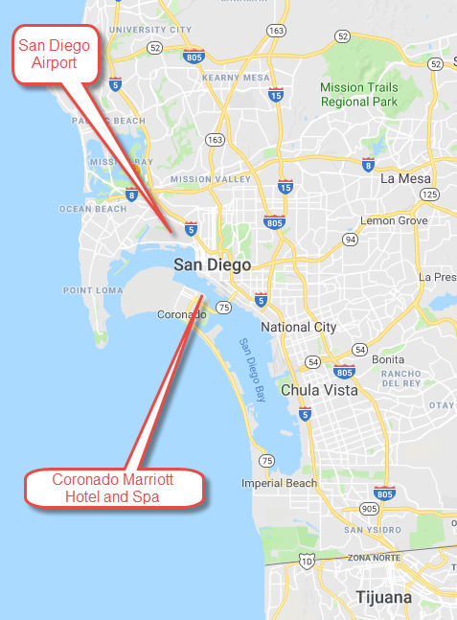
Directions from San Diego International Airport (SAN), 3225 N Harbor Dr, San Diego to Coronado Marriott Resort and Spa, 2000 2nd St. Coronado.
Head east on N Harbor Dr toward McCain Rd(2.3 miles)
Turn left onto W Grape St (0.4 miles)
Take the Interstate 5 S ramp (0.2 miles)
Merge onto I-5 S (2.4 miles)
Take exit 14A for CA-75 toward Coronado (0.4 miles)
Continue onto CA-75 S/San Diego – Coronado Bridge (1.9 miles)
Turn right onto Glorietta Blvd (0.2 miles)
Estimated Travel Time: 7.8 mi. About 15 mins
Downtown San Diego and Coronado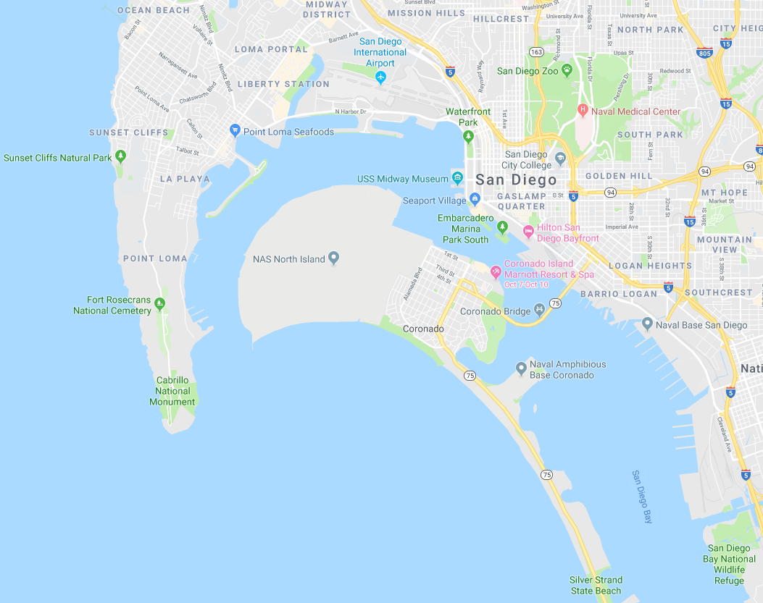
Restaurants near Coronado Marriott Resort & Spa
Current Restaurant at Coronado Island Marriott. Cuisines: American
Union Kitchen & Tap, 333 5th Ave, 1.0 miles from Marriott. Cuisines: Pub food

Il Fornaio, 1333 1st St - 0.3 miles from Marriott. Cuisines: Italian
Peohe's: 1201 1st Street - 0.3 miles from Marriott. Cuisines: American, Seafood
Tartine:1106 1st St - 0.4 miles from Marriott. Cuisines: Cafe
Village Pizzeria Bayside: 1201 1st St Coronado Ferry Landing, 0.4 miles from Marriott. Cuisines: African, Middle Eastern, Polynesian
Coronado Brewing Company: 170 Orange Ave, 0.5 miles from Marriott. Cuisines: American, Bar, Pub, Contemporary
Saiko Sushi: 116 Orange Ave, 0.5 miles from Marriott. Cuisines: Japanese, Sushi, Asian
Coronado Ferry to Downtown SD
Broadway Pier To Coronado | Coronado Ferry Landing To Broadway  (Downtown SD)
9:00 AM | 9:30 AM
10:00 AM | 10:30 AM
11:00 AM | 11:30 AM
12:00 PM | 12:30 PM
1:00 PM | 1:30 PM
2:00 PM | 2:30 PM
3:00 PM | 3:30 PM
4:00 PM | 4:30 PM
5:00 PM | 5:30 PM
6:00 PM | 6:30 PM
7:00 PM | 7:30 PM
8:00 PM | 8:30 PM
9:00 PM | 9:30 PM
10:00 PM* (Friday and Saturday only) | 10:30 PM*
Departures and Ferry Tickets purchases: Coronado Ferry Landing (1201 First St. Coronado); Broadway Pier (990 N. Harbor Drive, SD); Convention Center (600 Convention Way, SD).
Ticket price $4.75 each way.

Coronado to Downtown Ferry Map
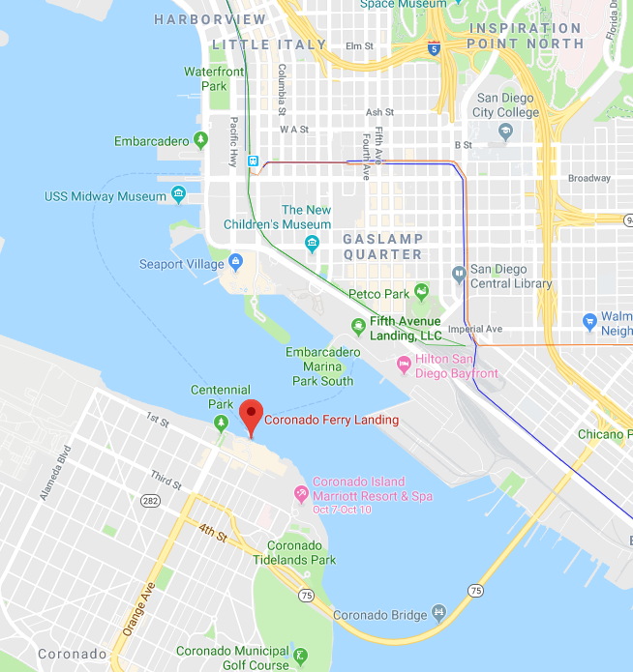

San Diego Area Attractions

San Diego Zoo
2920 Zoo Dr
6.7 miles NE from Hotel
SeaWorld® San Diego
500 Sea World Dr
11.9 miles NW from Hotel
Coronado Beach
1.8 miles SW from Hotel
Wild Animal Park
15500 San Pasqual Valley Rd
5.6 miles NE from Hotel
Balboa Park
1549 EL PRADO
5.6 miles NE from Hotel
Gaslamp Quarter
5th Avenue between K and Broadway
4.7 miles NE from Hotel
Seaport Village
849 West Harbor Drive
7 miles NE from Hotel
LEGOLAND® California Resort
1 Legoland Dr
38.4 miles NW from Hotel
Disneyland®/Disney California Adventure® Park
1313 S. Harbor Blvd.
99.5 miles NW from Hotel
Boardwalk bike path
2000 Second Street
0.1 miles E from Hotel
Old Town State Historic Park
4016 Wallace Street
10 miles NE from Hotel
Little Italy, San Diego
India Street
8 miles NE from Hotel
Birch Aquarium
2300 Expedition Way
20 miles N from Hotel
PETCO Park - home of MLB San Diego Padres
100 Park Blvd
3 miles from hotel
USS Midway Aircraft Memorial
900 N. Harbor Drive
8 miles N from Hotel

